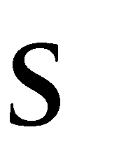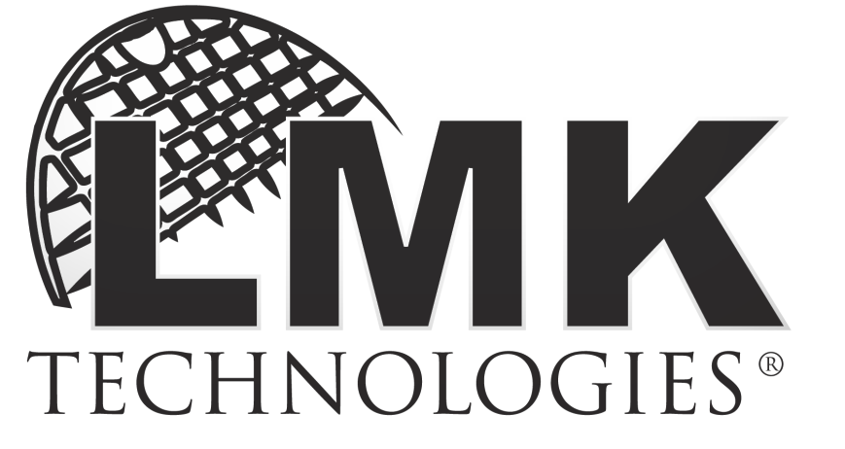

This document is Confidential Information developed and owned by LMK Technologies, LLC. This document is not intended for transmission to, or receipt by, any unauthorized persons. If you have received this document in error, please (i) do not read it, (ii) contact LMK Technologies at 1- 815-433-1275 to inform LMK Technologies under what circumstance the message was received, and (iii) erase or destroy the document.

LMK Technologies. 1779 Chessie Ln Ottawa IL 61350. Phone: 815.433.1275. Fax: 815.433.0107

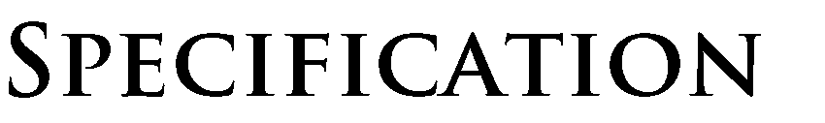Intent

It is the intent of this specification to detail a safe, efficient, cost-effective installation method of Insignia™ O-Ring hydrophilic compression sealing gaskets for creating a compression gasket seal at the ends of CIPP Liners. This hydrophilic sealing product is intended for use in conjunction with most all Cured in-place pipe rehabilitation systems, including but not limited to: inverted CIPP liners, pull-in-place CIPP liners, and fold-and-form plastic pipe liners. The Insignia™ O-Ring product shall be commercially available from LMK Technologies or a distributor for use as an adjunct to rehabilitative pipe lining projects on a price per kit basis.

Overview

  - The Insignia™ O-Ring product and process consists of providing a full-circle seal at the ends and overlapping points of a liner by using a cylindrical ring of hydrophilic material specifically tailored to provide cured in place pipe installation with a level of water-tight compression gasket sealing comparable to new piping installation at the ends of a Cure in-Place liner.

  - The Insignia™ O-Ring product and process consists of a hydrophilic material that does not shift or move during installation of a cured in-place rehabilitative pipe liner. Additionally, the Insignia™ O-Ring product provides a uniform seal and consistent wall thickness around the pipe end after installation of a pipe liner. Furthermore, the Insignia™ O-Ring product does not require arduous cleaning of the pipe end before installation.

  - Two methods are commonly utilized and associated with the installation of Insignia™ O- Rings. For pull in place liners, the O-Ring is frangibly attached to the resin-saturated CIPP liner. When the liner is inflated and the resin is cured the O-Ring becomes embedded between the liner and host pipe. For inverted Cured in-Place liners, the Insignia™ O-Ring is attached to the inside of the liner before resin saturation. Upon inversion of the resin- saturated liner, the O-ring is positioned between the liner and the host pipe, and upon contact with water the O-Ring swells effectively creating a compression gasket seal.

Material

  - The materials utilized for the Insignia™ O-Ring shall be provided in kits designed to accommodate varying pipe diameters, manhole depths, junction configurations, and cured in place liner products. The Insignia™ O-Ring kits are compatible with most cured in place rehabilitative pipe liner products, including cured-in-place, and fold-and-form Additionally, the Insignia™ O-Ring kit may be used with many different pipe liner installation and curing methods, including inversion, pull-in-place, hot water curing, steam curing, ultra violet curing, and ambient curing methods.

  - Cylindrical Ring: The member that creates the O-Ring is a hydrophilic neoprene rubber of approximately 50 Shore A durometer. The tubular sleeve has a uniform wall thickness of approximately 2 mm, a length of approximately 3.5 inches, and a diameter slightly less than the interior pipe diameter. The hydrophilic neoprene rubber has the following characteristics:

Characteristic | Unit | Value | Test Method
Shore A Hardness | point | 50 +/- 5 | ASTMD2240
Tensile Strength | psi | 177 | ASTMD412
Elongation at Break | % | 523 | ASTMD412
Specific Gravity |  | 1.2 | ASTMD297

  - Sizes: The Insignia O-Rings are available in sizes of 4”, 5”, 6”, 8”, 10”, 12”, 15”, 18”, 21”,
24”, 27”, 30”, 36”, 42”, and 48”.

  - Adhesive: For installing Cured in Place liners with the inversion process, adhesive may be used to attach the Insignia™ O-ring to the inside of the liner. The adhesive enables the O- Ring to remain in position during installation of the liner through the process of inversion.

Installation Recommendations

  - Access: Since the O-Rings are placed on the liner above ground, access to a manhole is not required. However, access to the manhole maybe required for the liner installation process depending on the type of repair. To determine the size of the Insignia™ O-Rings, the pipe interior at the manhole shall be measured from 6:00 to 12:00 and from 3:00 to 9:00. The mean shall be the nominal inner diameter.

  - Cleaning and Inspection: All roots, deposits, and debris should be removed from the pipe with hydraulically powered equipment, high velocity jet cleaners, or mechanically powered equipment as per NASSCO recommended specifications for sewer collection system rehabilitation. Since the Insignia™ O-Ring provides a seal based on compression instead of adhesion, extensive cleaning beyond obvious obstructions is optional. A full-circle seal at the ends of the liner will be achieved regardless of the presence of fats, oils, and grease which is inherent in sewer pipes even after high velocity jet cleaning. It should be noted that the various pipe rehabilitation installation methods have different installation standards (such as ASTM standards and manufacturer’s recommendations), and those installation standards should be observed during installation of the liner.

  - Installation of a Rehabilitative Liner: After the Insignia™ O-Ring product has been placed on the liner, the rehabilitative liner product shall be installed into the pipe. The Insignia™ O- Ring product is intended for use in conjunction with most pipe rehabilitation systems, including but not limited to: cured-in-place pipe liners and fold-and-form pipe liners. The Insignia™ O-Ring kit may be used with many different pipe liner installation and curing methods including, inversion, pull-in-place, hot water curing, steam curing, ultra violet curing, and ambient curing. Since the Insignia™ O-Ring product has a uniform wall thickness and is held firmly within the pipe to be rehabilitated, a compression seal will be provided at the end of the liner. Since the Insignia™ O-Ring product may be used with a variety of rehabilitative pipe liners, the standard installation practices of each individual pipe liner method should be closely followed. Procedures that meet applicable NASSCO, ASTM, NACE and SSPC standards and provide quality assurance controls that meet the manufacturer’s printed recommendations should be used.

© 2021 by LMK Technologies. All rights reserved.

Revised August 25, 2021

Document #1558

